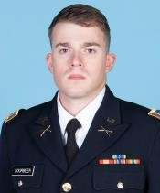

CPT JOSHUA SOURBEER

US ARMY SIMULATIONS OFFICER

2700 CHEVAL ST #104, ORLANDO FL 32828

[JSOURBEER999@GMAIL.COM;](mailto:JSOURBEER999@GMAIL.COM)

412-918-6233

# OBJECTIVE MILITARY WORK EXPERIENCE

Experienced Military Officer,

with a background as an Infantry Platoon Leader and current technical expertise as a Simulation Officer; currently enrolled at UCF in Modeling/Simulation MA

* **Pennsylvania National Guard (2013-2017)**
* **Platoon Leader, Unit Movement Officer, 3D Cavalry Regiment (2018-2020)**
* **MTC Chief of Small Unit Training (2021-2024)**
  + Daily Management of Virtual Battlespace 3 Suites and Other Virtual Simulations

# WORK EXPERIENCE CIVILIAN EDUCATION & RELEVANT SKILLS

* + - **University of Pittsburgh at Bradford (2013-2017)**
* Managed a portfolio of approximately 50 Military Simulations for Soldier Training
* Supervised a staff of 15 contracted employees inside a large organization providing simulation support to Army units throughout the Pacific.
* Managed a suite of 7 vLANs with associated Network Devices (Switches, Servers, Domain Controllers, Wire Infrastructure, and over 300 Gaming Computers)
* Oversaw tasks such as Software Sprints, Hardware Upgrades, Digital Terrain, Model and Building Creative Projects, Verification, Validation and Accreditation of Gaming Based Simulation Enablers
  + Varsity Athlete (Soccer & Cross Country)
  + Summa Cum Laude, 3.82 GPA
  + Minor in Forensics
* **University of Central Florida (2024-Present)**
  + Current GPA: 4.0
* **3 Years Experience Using Blender, for Digital Asset Creation, 3D Model Building**
* **2 Years Experience in C#, Red Hat Linux, VBA**
* **1 Year Experience in Java Script, Python**
* **2 Years Experience With Unreal Engine/Unity**

# CERTIFICATIONS, SCHOOLS

* Army Simulations Operations Course (SOC)
* Certified Modeling & Simulation Professional Certification (National Training & Simulation Association)
* Comptia Security Plus/Network Plus

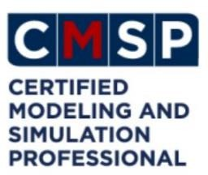

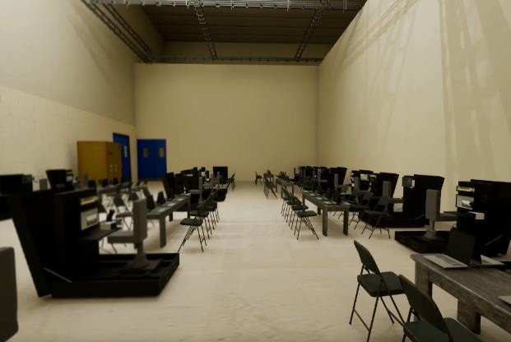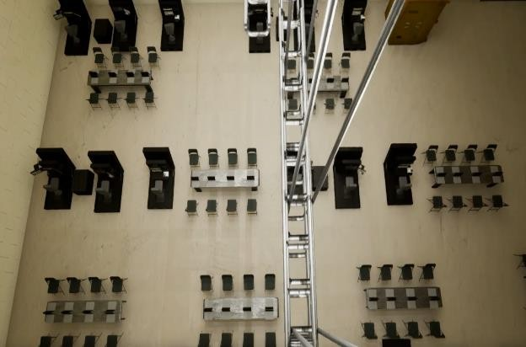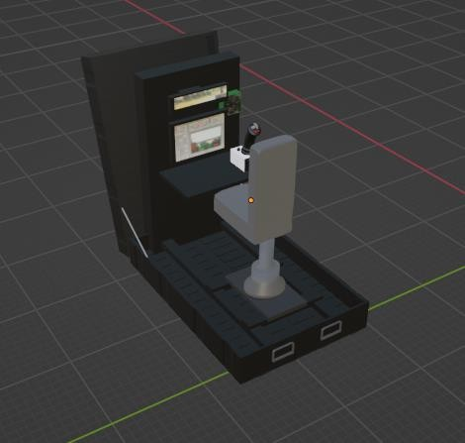

Created an Accurately Scaled 3D Blueprint of a Large Bay and New PEO-STRI built Simulators. Created from Scratch in Blender, Rendered in UE5. This Enabled Senior Leaders (O5 & GS14) to Visualize Over $6 Million Dollars Work of Complex Simulation Equipment in a Templated Location, Saving Installation Time and Money in Future Years.

Relevant Technical Skills & Portfolio

Created Various Other 3D Models of US Army Simulators For Use In Routine Capabilities Briefings Attended By Commanders, Non-Commissioned Officers, and Various Senior Leaders Including Several Two and Three Star General Officers and Civilian O6 Equivalents (GS14-15)

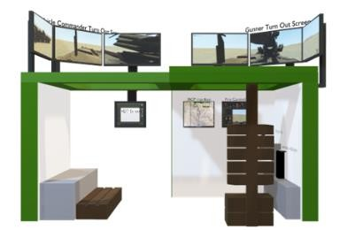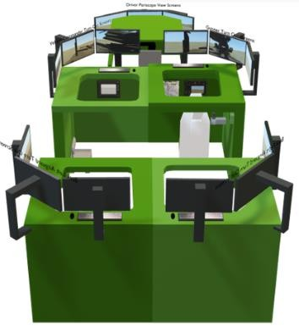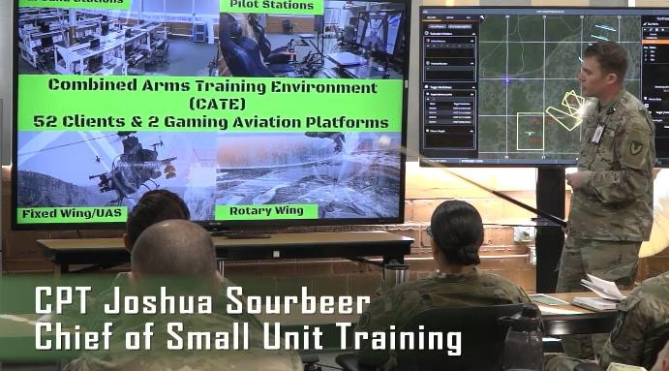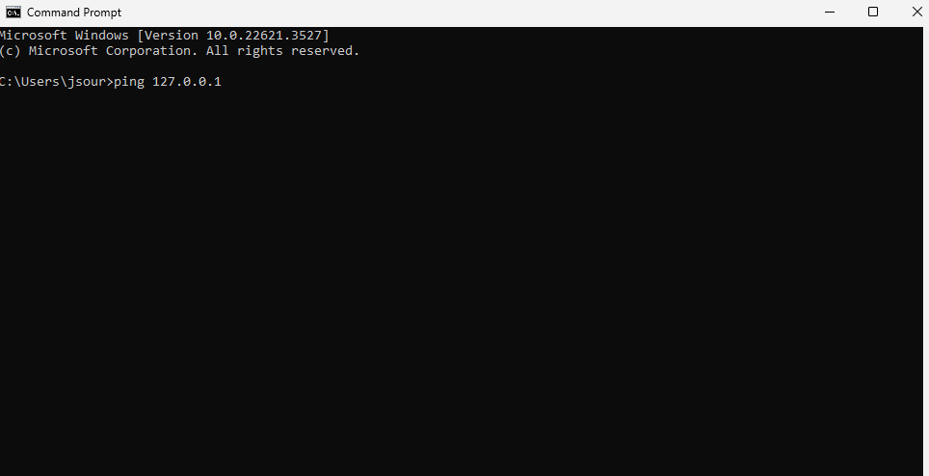

Wide Variety of Technical Knowledge in OSI Layer 1-3 Troubleshooting and Network Management to Include Sys Admin level of knowledge on CMD Prompt, Linux, C# and Visual Basic. Wrote a Visual Basic Macro Enabled Script to Allow Gaming Instructors to Ping all 400 Games for Training Laptops at MTC-JBLM. Managed and Provided Government Oversight to a small staff of 13x Gaming/Training Instructors and 2x System Administrators. Guided an Organization Through Various Hardware/Software Upgrades, License Renewals, New Equipment Issuances, Windows Upgrades, Etc. Currently developing an RPG Game and Mobile Application.